Bangladesh Medical Association (BMA)
List of Life Member-131
62. BMA Sirajganj Branch

Sl No | Voter No | Voter Details
1 | Voter No  LM-6200001  No Image | DR. A. M. MOSADDEQUE  F/Name:  M/Name:  BM & DC Reg. No:  NID:  Cell:  Address: Datta Bari, Sirajgonj  Blood Group:
2 | Voter No  LM-6200002  No Image | DR. MD. SUJA BAZZAMAN  F/Name:  M/Name:  BM & DC Reg. No:  NID:  Cell:  Address: Soya Bobinda, Thana Road, Sirajgonj, E X P I R E D  Blood Group:  E X P I R E D
3 | Voter No  LM-6200003  No Image | DR. MD. ASHRAFUL ISLAM  F/Name:  M/Name:  BM & DC Reg. No:  NID:  Cell:  Address: I.H Shiraji Road, Am-Bagan, Sirajgonj  Blood Group:
4 | Voter No  LM-6200004  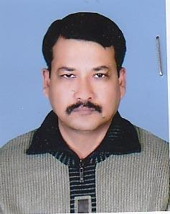 | DR. MD. NAZMUL HAQUE  F/Name: Late Sirajul Haque  M/Name:  BM & DC Reg. No:  NID:  Cell:  Address: G.M.Hilali Road, Sirajgonj  Blood Group:
5 | Voter No  LM-6200005  No Image | DR. MD. YOUSUF TALUKDER  F/Name: Md. Elias Uddin  M/Name:  BM & DC Reg. No:  NID:  Cell:  Address: M.E.C Eye Hospital, J.C Road, Dhanbandi, Sirajgonj  Blood Group:
6 | Voter No  LM-6200006  No Image | DR. S.A.D MD. REZAUL KARIM  F/Name: Late Abdul Aziz  M/Name:  BM & DC Reg. No:  NID:  Cell:  Address: Sirajganj X-Ray Clinic, E.B. Road, Sirajgonj  Blood Group:  E X P I R E D
7 | Voter No  LM-6200007  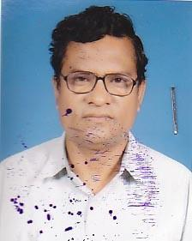 | DR. ZAHURUL HAQUE RAZA  F/Name: Late Abdul Karim  M/Name:  BM & DC Reg. No:  NID:  Cell:  Address: Kachari Para, New Gogra, Road, Sirajgonj.  Blood Group:
8 | Voter No  LM-6200008  No Image | DR. MD. ABDULLAH IS SAAD  F/Name: Late Shamsul Islam  M/Name:  BM & DC Reg. No:  NID:  Cell:  Address: Junior Consultant,General Hospital, Sirajgonj  Blood Group:
9 | Voter No  LM-6200009  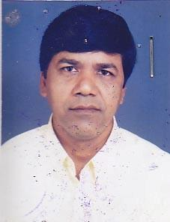 | DR. MD. AKRAMUZZAMAN  F/Name: Late Taleb Ali Sarker  M/Name:  BM & DC Reg. No:  NID:  Cell: 01711384512  Address: Pathologist, General Hospital, Sirajgonj  Blood Group:
10 | Voter No  LM-6200010  No Image | DR. M.A AWAL  F/Name: Md. Abdul Gofur  M/Name:  BM & DC Reg. No:  NID:  Cell:  Address: Transffered to BMA Dhaka City  Blood Group:  E X P I R E D
11 | Voter No  LM-6200011  No Image | DR. MASUD BIN RASHID  F/Name: Mr. A.h. Bazlur Rashid  M/Name:  BM & DC Reg. No:  NID:  Cell:  Address: B.N.S.B Eye Hospital, Sirajgonj  Blood Group:
12 | Voter No  LM-6200012  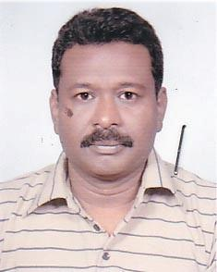 | DR. MD. ABDUS SAMAD AZAD  F/Name: Late Sohrab Ali  M/Name:  BM & DC Reg. No:  NID:  Cell:  Address: Thana Para, Sirajgonj  Blood Group:
13 | Voter No  LM-6200013  No Image | DR. MD. NURUL ISLAM  F/Name: Late Iman Ali  M/Name:  BM & DC Reg. No:  NID:  Cell:  Address: T.H. & F.P.O Kaz Pur, Sirajgonj  Blood Group:
14 | Voter No  LM-6200014  No Image | DR. MD. MOZAHER HOSSAIN  F/Name: Md. Moazzem Hossain  M/Name:  BM & DC Reg. No:  NID:  Cell:  Address: T.B Clinic, Sirajgonj  Blood Group:
15 | Voter No  LM-6200015  No Image | DR. ABU AHMED SHAHIDULLAH  F/Name: Wasim Uddin Ahmed  M/Name:  BM & DC Reg. No:  NID:  Cell:  Address: Ibne Sina General Hospital, Bahirgola, Sirajgonj  Blood Group:
16 | Voter No  LM-6200016  No Image | DR. MD. REAZUL ISLAM  F/Name:  M/Name:  BM & DC Reg. No:  NID:  Cell:  Address: TRANSFERED to BMA Rangpur Branch, LM-5700071.  Blood Group:  TRANSFERED to BMA Dhaka City  LM-1405543
17 | Voter No  LM-6200017  No Image | DR. MONOWARA KHATUN  F/Name:  M/Name:  BM & DC Reg. No:  NID:  Cell:  Address: Sirajgonj, TRANSFERED to BMA Rangpur Branch,LM-5700072  Blood Group:  TRANSFERED to BMA Dhaka City  LM-1405543
18 | Voter No  LM-6200018  No Image | DR. S.M. HAIDER ALI  F/Name: Late Al Haj Mozzeum Hossain  M/Name:  BM & DC Reg. No:  NID:  Cell:  Address: Fahana Clinic, Gandhail Bazar, Kazipur Sirajgonj  Blood Group:
19 | Voter No  LM-6200019  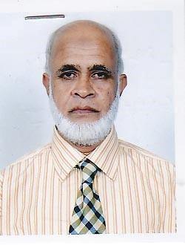 | DR. SHEIKH MOAZZEM HOSSAIN  F/Name: Sheikh Mojibor Rahman  M/Name:  BM & DC Reg. No:  NID:  Cell:  Address: Thana Road, Shoyagobinda, Sirajgonj  Blood Group:
20 | Voter No  LM-6200020  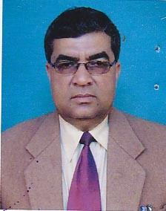 | DR. MS. LUTFOR RAHMAN  F/Name: Md. Abdul Gofur  M/Name:  BM & DC Reg. No:  NID:  Cell:  Address: Sergical Specialist Kanarkhond THC Sirajgonj.  Blood Group:
21 | Voter No  LM-6200021  No Image | DR. A.K.M NURUZZAMAN  F/Name: Md. Osman Gani  M/Name:  BM & DC Reg. No:  NID:  Cell:  Address: Hossain Pur Post & Dist. Sirajgonj  Blood Group:
22 | Voter No  LM-6200022  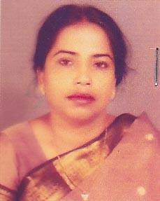 | DR. FARIDA KHATOON  F/Name: Late Farman Ali  M/Name:  BM & DC Reg. No:  NID:  Cell:  Address: Medical Office, Clinic, M.C.W.C Clinic, Sirajgonj  Blood Group:
23 | Voter No  LM-6200023  No Image | DR. SHAHIDUL ISLAM  F/Name: Late Md. Sadeque Ali Talukder  M/Name:  BM & DC Reg. No:  NID:  Cell:  Address: Janok Janoni, Hossainpur, Sirajgonj  Blood Group:
24 | Voter No  LM-6200024  No Image | DR. ABDUL AZIZ SARKER  F/Name: Md. Osman Goni Sarker  M/Name:  BM & DC Reg. No:  NID:  Cell:  Address: Moktar Para, Sirajgonj  Blood Group:
25 | Voter No  LM-6200025  No Image | DR. NITTYA RANJAN PAUL  F/Name: Rabindra Nath Paul  M/Name:  BM & DC Reg. No:  NID:  Cell:  Address: Sirajgonj Poly Clinic, Station Road, Sirajgonj  Blood Group:
26 | Voter No  LM-6200026 | DR. S.M QUAMRUL HASAN PARVEZ  F/Name: Late Abdul Jalil  M/Name:  BM & DC Reg. No:  NID:  Cell:  Address: Medical Officer, General Hospital, Sirajgonj  Blood Group:
27 | Voter No  LM-6200027  No Image | DR. A.K.M. MOQSUDUL HASAN  F/Name:  M/Name:  BM & DC Reg. No:  NID:  Cell:  Address: Junior Consultant (C.C) & OBS, General Hospital, Sirajgonj  Blood Group:
28 | Voter No  LM-6200028  No Image | DR. AFM NOWSHER ALI  F/Name: Late Md. Ebrahim Fakir  M/Name:  BM & DC Reg. No:  NID:  Cell:  Address: Deputy Civil Surgeon, Sirajgonj.  Blood Group:
29 | Voter No  LM-6200029  No Image | DR. MD. ALTAF HOSSAIN  F/Name:  M/Name:  BM & DC Reg. No:  NID:  Cell:  Address: Upazila- Ullapara, Government Quarter, Ullapara, Sirajgonj  Blood Group:
30 | Voter No  LM-6200030  No Image | DR. MS. SAIFUL ISLAM  F/Name:  M/Name:  BM & DC Reg. No:  NID:  Cell:  Address: Medical Officer , MATS, Sirajgonj  Blood Group:
31 | Voter No  LM-6200031  No Image | DR. MIZANUR RAHMAN  F/Name: Motiur Rahman  M/Name:  BM & DC Reg. No:  NID:  Cell:  Address: Civil Surgeon, Sirajgonj.  Blood Group:
32 | Voter No  LM-6200032  No Image | DR. MD. ABDUL MANNAN  F/Name: Late Nasir Uddin Sarker  M/Name:  BM & DC Reg. No:  NID:  Cell:  Address: Managing Director, Chandaikona Hospital, Chandaikona Raigonj, Sirajgonj.  Blood Group:
33 | Voter No  LM-6200033 | DR. MD. AMINUL ISLAM SHEIKH  F/Name: Late. Mohir Uddin Sheikh  M/Name: Amiron Begum  BM & DC Reg. No: 23248  NID: 8827812181181  Cell: 01711013533  Address: Junior consultant (child), General hospital, Sirajgonj  Blood Group: B+
34 | Voter No  LM-6200034 | DR. MD. WALIUL ISLAM TALUKDER  F/Name: Md. Ayez Uddin Talukder  M/Name: Mst. Fazilatun Nessa  BM & DC Reg. No: 21495  NID: 8827801101736  Cell: 01711157816  Address: Prime Diagnostic Complex, near bus stand, Kachari para, Sirajgonj  Blood Group: B+
35 | Voter No  LM-6200035 | DR. MST. SHAKINA KHATUN  F/Name: Late. Abdus Shahid Khan  M/Name: Mst. Maleka Khatun  BM & DC Reg. No: 30818  NID: 8827801101735  Cell: 01712534812  Address: Prime Diagnostic & Comp;ex, Near Bus stand, Kachari Para, Sirajgonj  Blood Group: AB+
36 | Voter No  LM-6200036  No Image | DR. SAILENDRA NATH BISWAS  F/Name: Late Profulla Kumar  M/Name:  BM & DC Reg. No:  NID:  Cell:  Address: Medicine, Khaja Younus Ali Medical College Hospital, Sirajgonj.  Blood Group:
37 | Voter No  LM-6200037  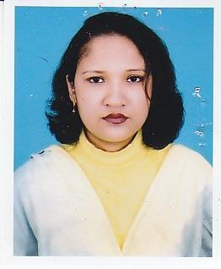 | DR. SHAHIDA BEGUM  F/Name: Late. Delwar Hossain  M/Name: Hosne Ara Begum  BM & DC Reg. No: 25751  NID: 8812747100573  Cell: 01745249625  Address: Assosiate Professor, (obstetrics & Gyneocology), Khwaja Yunus Ali Medical College and Hospital, Enayetpur, Sirajgonj  Blood Group: O+
38 | Voter No  LM-6200038  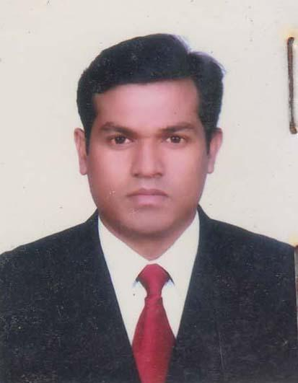 | DR. MOHAMMAD KAMRUL RASEL KHAN  F/Name: Mohammad Anser Ali Khan  M/Name: Rabeya Khatun  BM & DC Reg. No: 41929  NID: 1926713133727  Cell: 01711701611  Address: Sirate Road, Mukter Para, Sirajgonj  Blood Group: O+
39 | Voter No  LM-6200039  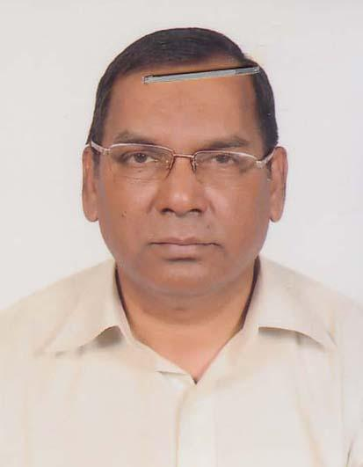 | DR. MD. ISRAIL HOSSAIN  F/Name: Late Sk. Mofizuddin  M/Name: Late. Romesa Khatun  BM & DC Reg. No: 10938  NID: 8827812177970  Cell: 01717481729  Address: 269, Kalibari Road, Sirajgonj  Blood Group: B+
40 | Voter No  LM-6200040  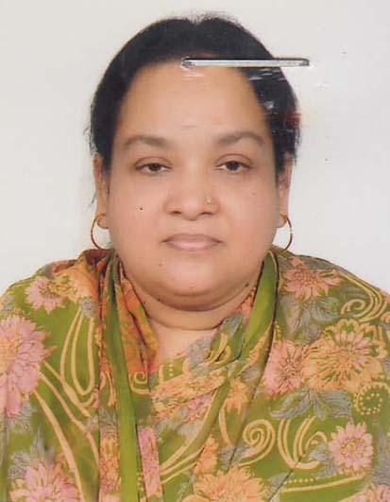 | DR. SHAMIMA AZIZ  F/Name: Md. Azizul Haq  M/Name: Mrs. Khaleda Begum  BM & DC Reg. No: 17479  NID: 8827812177944  Cell: 01711236171  Address: 269 Kalibari Road, Sirajgonj  Blood Group: A+
41 | Voter No  LM-6200041  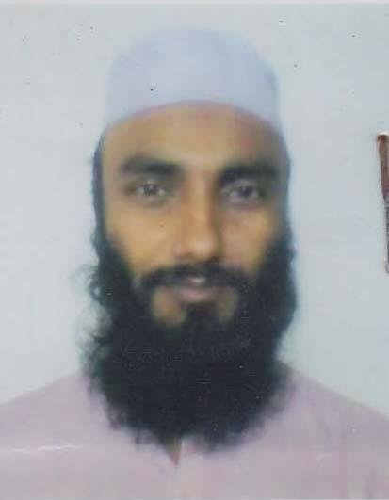 | DR. SHAFIQUL ISLAM  F/Name: Md. Chan Khan  M/Name: Sufia Begum  BM & DC Reg. No: 36128  NID: 8827803121089  Cell: 01719533580  Address: S.B. Fazlul Haque Road, Gosala(Kali Mundir), Sirajgonj  Blood Group: O+
42 | Voter No  LM-6200042  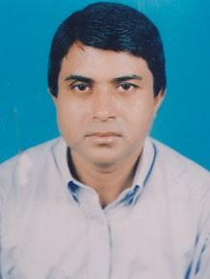 | DR. MD. OSMAN GHANI SHAMIM  F/Name: Al-haj Md. Asker Ali  M/Name: Late. Ramesha Khatun  BM & DC Reg. No: 14780  NID:  Cell: 01681678571  Address: Consultant Cardiology, General Hospital, Sirajgonj  Blood Group: O+
43 | Voter No  LM-6200043  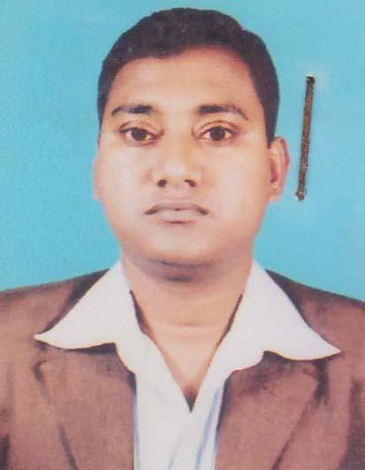 | DR. MD. JAHIDUL ISLAM  F/Name: Md. Shahjahan Ali  M/Name: Most. Jamsheda Jahan  BM & DC Reg. No: 50505  NID: 8827808149072  Cell: 01710724489  Address: Janpur Bank para, Sirajgonj  Blood Group: O+
44 | Voter No  LM-6200044  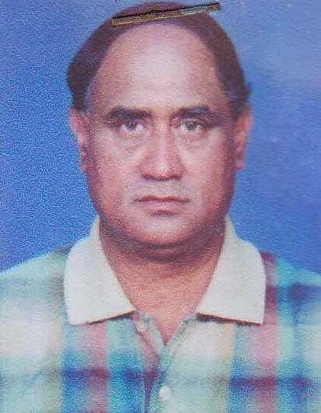 | DR. SHA CHINDRA NATH BASAK  F/Name: Babu Shasadhar Basak  M/Name: Late. Chhabi Rani Basak  BM & DC Reg. No: 8864  NID: 8816119698238  Cell: 01712207102  Address: Principal, MATS, Sirajgonj  Blood Group: A+
45 | Voter No  LM-6200045  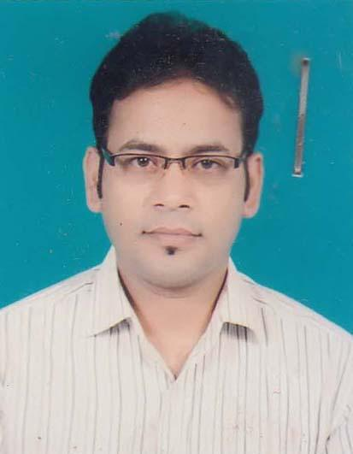 | DR. MD. MERAZUL ISLAM SHAIKH  F/Name: Late. Nur Mohammad Shaikh  M/Name: Mst. Rahima Khatun  BM & DC Reg. No: 39813  NID: 8817817284762  Cell: 01716034806  Address: Assistant register(M), General Hospital, Sirajgonj  Blood Group: B+
46 | Voter No  LM-6200046  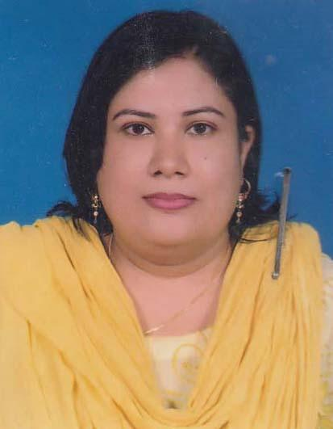 | DR. ZINAT FARZANA  F/Name: Md. Anisur Rahman Khan  M/Name: Anjuman Ara  BM & DC Reg. No: 36929  NID: 8827812181171  Cell: 01719242592  Address: Moinuddin Memorial Hospital, M.A Motin Road, bus stand Sirajgonj  Blood Group: A+
47 | Voter No  LM-6200047  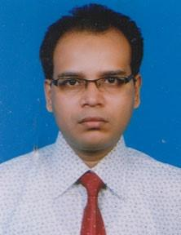 | DR. MD. RABIUL KARIM  F/Name: Nur Mohammad Sarker  M/Name: Zaheda Begum  BM & DC Reg. No: 38716  NID: 2694812077828  Cell: 01712596147  Address: Hospital Quarter, General Hospital, Sirajgonj  Blood Group: B+
48 | Voter No  LM-6200048  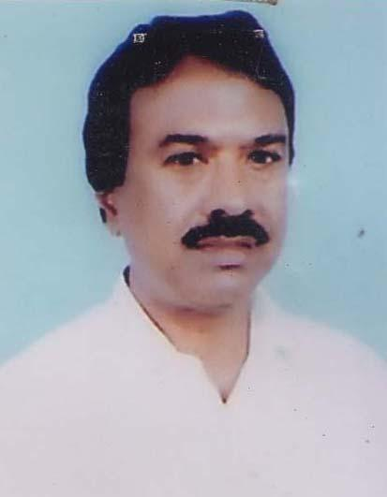 | DR. ABDUR RAZZAQUE  F/Name: Late. Suruzzaman  M/Name: Late. Zobeda Khatun  BM & DC Reg. No: 16301  NID: 8827803118140  Cell: 01712127220  Address: Consultant anathesiologist, Sirajgonj General Hospital  Blood Group: B+
49 | Voter No  LM-6200049  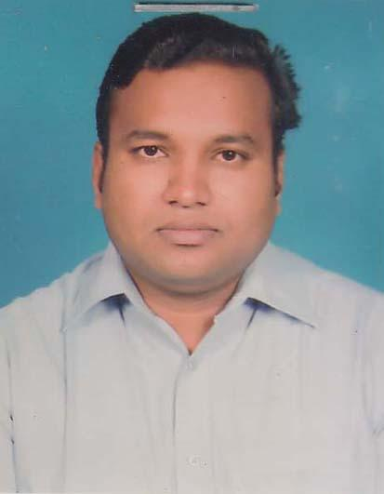 | DR. MD. FARUQ HOSSAIN  F/Name: Md. Abdus Salam  M/Name: Fatema Khatun  BM & DC Reg. No: 51449  NID:  Cell: 01712718370  Address: M/S Salam Traders, S.S Road, Sirajgonj  Blood Group: A+
50 | Voter No  LM-6200050  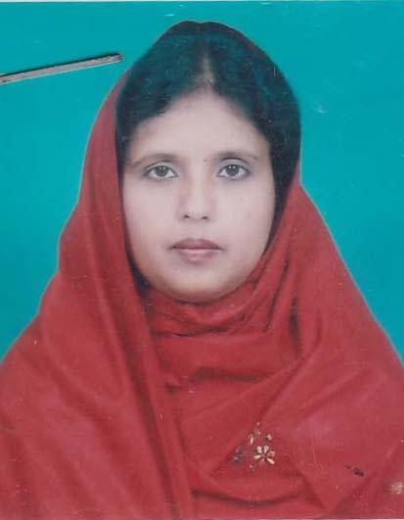 | DR. AKIKUN NAHER  F/Name: Md. Ali Akbar  M/Name: Mrs. Badrun Nahar  BM & DC Reg. No: 26088  NID: 8827812179102  Cell: 01711042486  Address: General Hospital Sirajgonj  Blood Group: A+
51 | Voter No  LM-6200051  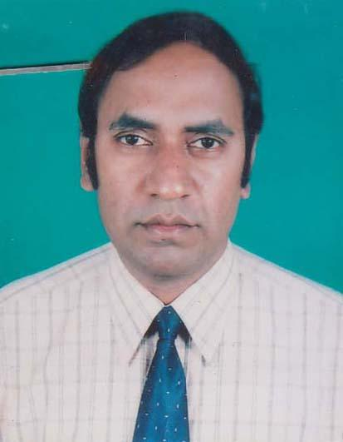 | DR. MD. ABU RAYHAN BHUIYAN  F/Name: Md. Tozammel Haque Bhuiyan  M/Name: Mrs. Zobeda Begum  BM & DC Reg. No: 22476  NID: 8827812181792  Cell: 01712499367  Address: Junior Consultant (surgery), Kamarkhand Upazila Health Complex, Sirajgonj  Blood Group: B+
52 | Voter No  LM-6200052  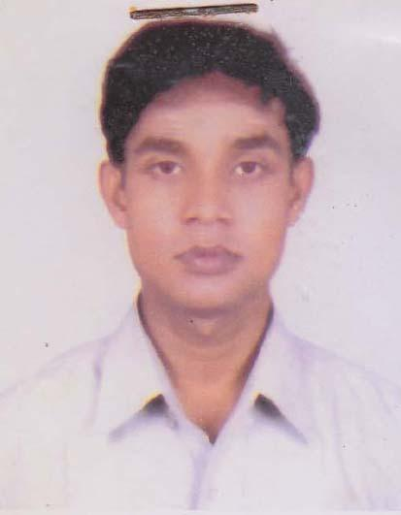 | DR. SUBAS CAANDRO DATTA  F/Name: Dhirendra Nat  M/Name: Momota Rani Datta  BM & DC Reg. No: 41740  NID: 8814419518520  Cell: 01199339287  Address: Akondo Traders, S.S. Road, Sirajgonj  Blood Group: O+
53 | Voter No  LM-6200053  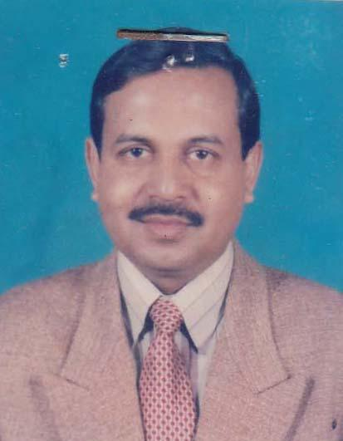 | DR. MD. SHAFIUL ISLAM  F/Name: Muin Uddin  M/Name: Laily Begum  BM & DC Reg. No: 18214  NID: 8827811174501  Cell: 01914495365  Address: Stadium Road , Sirajgonj  Blood Group: B+
54 | Voter No  LM-6200054  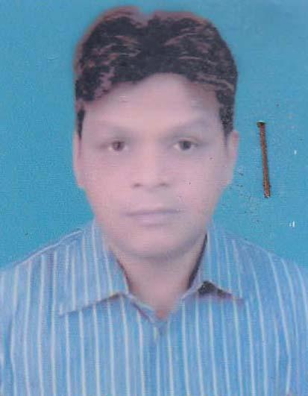 | DR. A. K. M. SHAHIDUR RAHMAN  F/Name: Late. Borhan Uddin  M/Name: Sufia Begum  BM & DC Reg. No: 25661  NID: 8827811170139  Cell: 01714121178  Address: Assistant Professor, Department of Pharmacology, Khwaja Yunus Ali Medical College, Enayetpur, Sirajgonj  Blood Group: A+
55 | Voter No  LM-6200055  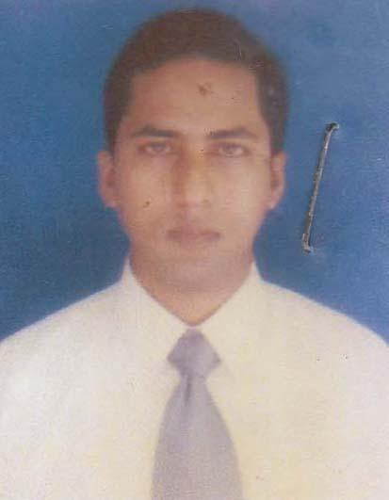 | DR. MD. SHARIFUL HAQUE  F/Name: Md. Nurul Haque  M/Name: Mrs. Saleha Haque  BM & DC Reg. No: 29186  NID: 8198508265357  Cell: 01818397669  Address: Register Medicine, Shaheed Ziaur Rahman Medical College Hospital , Sirajgonj.  Blood Group: AB+
56 | Voter No  LM-6200056 | DR. SHAHANA BEGUM  F/Name: Md. Habibur Rahman  M/Name: Late. Rezia Begum  BM & DC Reg. No: 27322  NID:  Cell: 01716578557  Address: Bahirgola Road,Sirajgonj  Blood Group: B+
57 | Voter No  LM-6200057  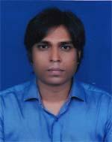 | DR. NIHAR RANJON DAS  F/Name: Nripendra Krishna Das  M/Name: Bela Rani Das  BM & DC Reg. No: 53307  NID: 8198510365085  Cell: 01730301743  Address: Dhambamdhi, J.C. Road, Sirajganj  Blood Group: B+
58 | Voter No  LM-6200058  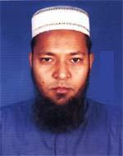 | DR. MD. ZAFRUL HOSSAIN  F/Name: Md. Asir Uddin  M/Name: Jahanara Begum  BM & DC Reg. No: 27468  NID: 8829404761062  Cell: 01711978546  Address: Upazila Health Complex, Shahzadpur, Sirajganj  Blood Group: AB+
59 | Voter No  LM-6200059  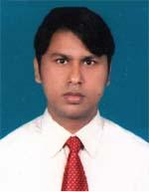 | DR. MD. MOKHLESUR RAHMAN  F/Name: Md. Shaihdul Islam  M/Name: Monowara Begum  BM & DC Reg. No: 42552  NID: 8816787596437  Cell: 01719362304  Address: Hazi Barak, S B Fazlul Haque Road, Sirajganj  Blood Group: A+
60 | Voter No  LM-6200060  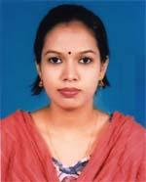 | DR. SHARMIN AKHTER  F/Name: Md. Mozibar Rahman  M/Name: Mrs. Selina Parvin  BM & DC Reg. No: 61494  NID: 19884798517248799  Cell: 01735161620  Address: Jubilee Bagan Lane, Sirajgonj Sadar, Sirajgonj  Blood Group: B+
61 | Voter No  LM-6200061  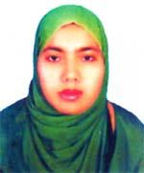 | DR. MAHMUDA ISLAM  F/Name: Md. Nur Islam  M/Name: Parul Islam  BM & DC Reg. No: 56871  NID: 19879322602050038  Cell: 01717498743  Address: Upazilla Health Complex, Shahjadpur, Sirajganj.  Blood Group: B+
62 | Voter No  LM-6200062  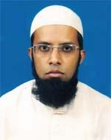 | DR. MD. SALIM AL MAMUN  F/Name: Md. Shahidul Islam  M/Name: Mst. Hafiza Khatun  BM & DC Reg. No: 46812  NID: 8827805496542  Cell: 01721463398  Address: Lecturer, Biochemistry Shaheed M. Monsur Ali Medical College, Sirajganj  Blood Group: O+
63 | Voter No  LM-6200063  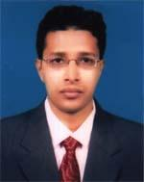 | DR. SM. ABU ELIAS  F/Name: Sk. Mohammad Ali  M/Name: Mrs. Rowshon- Ara- Begum  BM & DC Reg. No: 49952  NID: 8827805130131  Cell: 01779242210  Address: Jubilee Bagum Lane, Sirajgonj Sadar, Sirajgonj  Blood Group: B+
64 | Voter No  LM-6200064  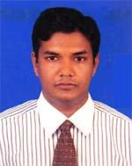 | DR. MD. SYFUL ISLAM  F/Name: Md. Abu Talha  M/Name: Ayesha Siddika  BM & DC Reg. No: 53657  NID: 2697556419172  Cell: 01757818972  Address: Shaheed. M. Monsur Ali Medical College , Sirajgonj  Blood Group: A+
65 | Voter No  LM-6200065  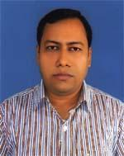 | DR. SAMAUNNUR SHUVO  F/Name: Dr. Md. Nurul Islam Talukder  M/Name: Merina Islam  BM & DC Reg. No: 49995  NID:  Cell: 01785449546  Address: Almahmood Avenue. Hossainpur, Sirajgonj  Blood Group: B+
66 | Voter No  LM-6200066  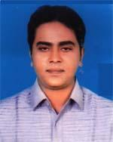 | DR. MD. RAFIQUZZAMAN  F/Name: Md. Ferdaus Ali  M/Name: Mrs. Rokeya Ferdaus  BM & DC Reg. No: 51879  NID: 8827802112132  Cell: 01712512555  Address: Vill-Diardhangora, Post-Diardhangora, P.S-Sirajgonj Sadar, Sirajgonj-6700  Blood Group: B+
67 | Voter No  LM-6200067  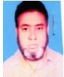 | DR. MD. ABDUL MOID  F/Name: Md. Abdul Hamid  M/Name: Mst. Mokasriur Banu  BM & DC Reg. No: 28972  NID:  Cell: 01716280440  Address: General Hospital Sirajgonj  Blood Group: A+
68 | Voter No  LM-6200068 | DR. MD. OMAR FARUK  F/Name: Md. Bodiuzzaman  M/Name: Fatema Khatun  BM & DC Reg. No: 54677  NID: 19872924709173736  Cell: 01740998999  Address: Vill-Janpur, Bankpara, Post+Dist-Sirajgonj  Blood Group: B+
69 | Voter No  LM-6200069  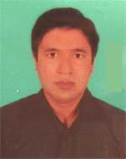 | DR. MD. REAZUL ISLAM  F/Name: Md. Altaf Hossain  M/Name: Most. Arina Khatun  BM & DC Reg. No: 54358  NID: 19808817816000001  Cell: 01711467618  Address: Vill-Bejganti, Post-Fulcocha, Dist-Sirajgonj  Blood Group: A+
70 | Voter No  LM-6200070 | DR. DIPOK SAHA  F/Name: Norendra Nath Saha  M/Name: Bina Saha  BM & DC Reg. No: 61585  NID: 4798516214752  Cell: 01717143021  Address: Bania Patty, Sirajgonj  Blood Group: O-
71 | Voter No  LM-6200071  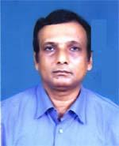 | DR. MD. NAZMUL ISLAM  F/Name: Md. Saiful Islam  M/Name: Nurjahan Islam  BM & DC Reg. No: 11569  NID: 8827812176166  Cell: 01711018301  Address: Atlul Khan Road, Amlapara, Sirajgonj  Blood Group: B+
72 | Voter No  LM-6200072  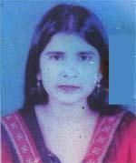 | DR. ANZUMAN ARA BOKUL  F/Name: Md. Abu Bakar Siddique  M/Name: Mrs. Lutfun Nesa  BM & DC Reg. No: 33184  NID: 8827808151632  Cell: 01712192695  Address: Janpor Bank Para, Post+Thana+Dist-Sirajgonj  Blood Group: A+
73 | Voter No  LM-6200073 | DR. MD. SHAHDAT HOSSAIN  F/Name: Late Zahural Haque  M/Name: Late Salena Khatun  BM & DC Reg. No: 3472  NID: 2690243844992  Cell: 01715157033  Address: 18, South Nazrul Sarayni (Bahirgola Road) Sirajgonj  Blood Group: AB+
74 | Voter No  LM-6200074  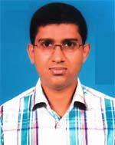 | DR. MD. JAHIDUL ISLAM  F/Name: Jahirul Haque  M/Name: Laily Begum  BM & DC Reg. No: 36286  NID: 2692985067811  Cell: 01712053831  Address: Soiadhangore Modhopara, Sirajgonj  Blood Group: O+
75 | Voter No  LM-6200075  No Image | DR. ZERIN TASNIM NOSHIN  F/Name: Late: Abul Hasnat  M/Name: Mrs. Tajlim Hasnat  BM & DC Reg. No: A44586  NID: 8827811169662  Cell: 01755-764753  Address: Address: Al-Mahmood Avenue, Sirjgonj.  Blood Group: B+
76 | Voter No  LM-6200076  No Image | DR. SHARMINA RAHMAN  F/Name: Md. Anisur Rahman  M/Name: Maksuda Bilkis Banu  BM & DC Reg. No: A 80499  NID: 5073201484  Cell: 01711-240158  Address: Address: Afzal Khan Road,Amlapara, Sirjgonj.  Blood Group: AB+
77 | Voter No  LM-6200077  No Image | DR. ZANNATUN NIME  F/Name: Shamsul Bari  M/Name: Shahida Bari  BM & DC Reg. No: A 71906  NID: 9122462238  Cell: 01737-496198  Address: Bahirgola Road, Gosh Para, Sirajgonj.  Blood Group: B+
78 | Voter No  LM-6200078  No Image | DR. MUHAMMAD ABDULLAHIL KAFI  F/Name: Muhammad Abdur Rashid  M/Name: Nurzahan Begum  BM & DC Reg. No: A 50939  NID: 8816138982838  Cell: 01717-673505  Address: Shaheed M. Monsur Ali Medical College, Sirajgonj  Blood Group: A+
79 | Voter No  LM-6200079  No Image | DR. TAMIMA SULTANA ELIN  F/Name: Md. Adam Ali Miah  M/Name: Mariom Begom  BM & DC Reg. No: A62990  NID: 8198510364106  Cell: 01711-274030  Address: Kalia, Horipur, Sirajgonj  Blood Group: O+
80 | Voter No  LM-6200080  No Image | DR. FERDOUSY YESMIN  F/Name: Md. Jahangir Hossain Khan  M/Name: Nurunnahar Khanom  BM & DC Reg. No: A83013  NID: 3748958430  Cell: 01723-819049  Address: Natun Vanga Bari, Sirajgonj.  Blood Group: B+
81 | Voter No  LM-6200081  No Image | DR. NOWSHIN YESMIN TONNY  F/Name: S M Abdul Mannan  M/Name: Rowshan Aktar  BM & DC Reg. No: A62792  NID: 8827810497315  Cell: 01788-130373  Address: 18/2, Shioqoli, hosne Dalan Road, Thana: Chakbazar, Dhaka  Blood Group: O+
82 | Voter No  LM-6200082  No Image | DR. MD. SHAMSHUL ALOM  F/Name: Md. Akbor Ali Mia  M/Name: Mrs. Aleya Begum  BM & DC Reg. No: A36721  NID: 19762697557395774  Cell: 01712169288  Address: Associate Professor Of Cardiology, North, Bangla Medical College Hospital, Sirajgong.  Blood Group: B+
83 | Voter No  LM-6200083  No Image | DR. SABAH AHSAN  F/Name: Mahbub Ahsan  M/Name: Jesmin Parvin  BM & DC Reg. No: A74855  NID: 6415066631674  Cell: 01723-578686  Address: Stuff Quarter, Nursing Institute, Sirajgonj  Blood Group: O+
84 | Voter No  LM-6200084  No Image | DR. UMME KULSUM LUCKY  F/Name: Md. Shahjahan Ali  M/Name: Most. Jamseda Jahan  BM & DC Reg. No: A 93735  NID: 8656383588  Cell: 01771377723  Address: Janpur (Bank Para) Sirajgonj  Blood Group: O+
85 | Voter No  LM-6200085  No Image | DR. S M SHAJADUR RAHMAN  F/Name: Romiz Uddin Ahmed  M/Name: Shajada Sultana  BM & DC Reg. No: A86754  NID: 3265442131  Cell: 01717-623146  Address: Janpur (Bank Para) Sirajgonj  Blood Group: A+
86 | Voter No  LM-6200086  No Image | DR. K. M. SHAKILA SULTANA BOBY  F/Name: K M Golam Abbas  M/Name: K M Aklima  BM & DC Reg. No: A60041  NID: 7343178229  Cell: 01761557757  Address: Janpur Bank Para, Sirajgonj Sadar, Sirajgonj.  Blood Group: AB+
87 | Voter No  LM-6200087  No Image | DR. MD. ABDUL AZIM SOBUJ  F/Name: Md. Joynal Abdin  M/Name: Arifa Khatun  BM & DC Reg. No: A84992  NID: 1460127093  Cell: 01747238153  Address: Masumpur Natun para, P.O: Sirajgonj,Sadar P.S/Dist: Sirajgonj -6700  Blood Group: B+
88 | Voter No  LM-6200088  No Image | DR. ABDULLAH AL MAMUN  F/Name: Late: Abdul Jalil Sarker  M/Name: Mst. Majeda Khatun  BM & DC Reg. No: A44585  NID: 8816787437804  Cell: 01717522230  Address: Al Mahmood Avenue, Hosenpur, sirajgonj  Blood Group: O+
89 | Voter No  LM-6200089  No Image | DR. AYED ARAFAT AL YASIN SHATIL  F/Name: Syed Monirul Huda Sabbir  M/Name: Syeda Suriya Parvin Bithi  BM & DC Reg. No: A85007  NID: 7321501152  Cell: 01717-626297  Address: Soyagobindo, MIlon More, Sirajgonj  Blood Group: AB+
90 | Voter No  LM-6200090  No Image | DR. RUKHSANA HOSSAIN QUEEN  F/Name: Md. Rabiul Hossain  M/Name: Monowara Begum  BM & DC Reg. No: A 82765  NID: 19938827802000146  Cell: 01792702196  Address: Senpara parbata, 431/3/1, Mirpur-10, Dhaka.  Blood Group: B+
91 | Voter No  LM-6200091  No Image | DR. CHAITY CHAKRABORTY  F/Name: Shikher Chakroborty  M/Name: Manashi Goshwami  BM & DC Reg. No: A71617  NID: 19918827802000134  Cell: 01794932863  Address: Thana Road, Sirjgonj  Blood Group: O+
92 | Voter No  LM-6200092  No Image | DR. MOUMITA PAUL  F/Name: Monoranjan Paul  M/Name: Provati Basak  BM & DC Reg. No: A 76411  NID: 19918827812000016  Cell: 01719201601  Address: Kalibari, Sirajgonj  Blood Group: A+
93 | Voter No  LM-6200093  No Image | DR. MD. NURUL ISLAM  F/Name: Abdus Samad  M/Name: Bedana Khatun  BM & DC Reg. No: A 62726  NID: 19878198510365095  Cell: 01737368884  Address: Vill: Chowpakia, P.O: Matia Mali Para, Thana: Taras, Sirajgonj  Blood Group: AB+
94 | Voter No  LM-6200094  No Image | DR. KANIJ FATEMA  F/Name: Md. Iqbal Hossain  M/Name: Inoor Naim  BM & DC Reg. No: A 70505  NID: 8817894362036  Cell: 01792476789  Address: Northbengal Medical College, Dhanbandhi, Sirajgonj  Blood Group: O+
95 | Voter No  LM-6200095  No Image | DR. MD. SHAWON SHAHREAIR  F/Name: Md. Sharif Ahmed  M/Name: Shirin Khan  BM & DC Reg. No: A 79722  NID: 19928827811000069  Cell: 01719132727  Address: Staff Quarter, Nursing instituted, Sirajgonj  Blood Group:
96 | Voter No  LM-6200096  No Image | DR. RUHUL AMIN TANG  F/Name: Md. Solaiman Ossain Tang  M/Name: Late: Aleya Khatun  BM & DC Reg. No: A 55589  NID: 8816185637590  Cell: 01723570578  Address: Sirajgonj Community Hospital, Mujib, Sarak, Sirajgonj  Blood Group: A+
97 | Voter No  LM-6200097  No Image | DR. RUBAIYA NAHAR  F/Name: Md. Abdur Razzaque  M/Name: Shamsunnahar  BM & DC Reg. No: A 63235  NID: 8199017366907  Cell: 01754400693  Address:  Blood Group: O+
98 | Voter No  LM-6200098  No Image | DR. AMBIA KHATUN BITHI  F/Name: Shofi Ahmed Talukder  M/Name: Monzuara Begum  BM & DC Reg. No: A 63197  NID: 19908829402000007  Cell: 01738405183  Address: 250 Beded General Hospital, Sirajgonj  Blood Group: O+
99 | Voter No  LM-6200099  No Image | DR. CHITRA GHOSH  F/Name: Gopal Chandra Ghosh  M/Name: Sharkuri Rani Ghosh  BM & DC Reg. No: A 69420  NID: 19908815017000035  Cell: 01725-447786  Address: Bahirgola, Gurer bazaar, Sirajgonj  Blood Group: O+
100 | Voter No  LM-6200100  No Image | DR. MD. KAISARUL ISLAM  F/Name: Md. Abdul Quddus  M/Name: Mst. Shaheena Parvin  BM & DC Reg. No: No. A 87103  NID: 5996075932  Cell: 01731134694  Address: Railway Colony, Sirajgonj  Blood Group:
101 | Voter No  LM-6200101  No Image | DR. TASNEEM BINTE KIBRIA  F/Name: Ghulam Kibria  M/Name: Kamrun Nahar  BM & DC Reg. No: 79727  NID: 19918827803000027  Cell: 01941132965  Address: Mostofa Plaza, S S Road, Sirajgonj  Blood Group:
102 | Voter No  LM-6200102  No Image | DR. MST. RUKHSANA PERVIN  F/Name: Md. Abdur Razzaque  M/Name: Maleka Khatun  BM & DC Reg. No: 63019  NID: 7026610165727  Cell: 01747237834  Address: Vill: Telkupi Notun Para, Post: Sirajgonj, P.S: Sirajgonj, Dist: Sirajgonj  Blood Group: B+
103 | Voter No  LM-6200103  No Image | DR. MOSTAFIZUR RAHMAN  F/Name: Mozammel Hossain  M/Name: Umme Salma  BM & DC Reg. No: 79725  NID: 19938827804000021  Cell: 01722400454  Address: Vill: Soyadhargora (North Para)P.O + Dist: Sirajgonj  Blood Group: B+
104 | Voter No  LM-6200104  No Image | DR. MIR. SHOFIKUL ISLAM  F/Name: Late: Amdd Ali Mir  M/Name: Mst. Shafali Khatun  BM & DC Reg. No: 53456  NID: 19848827810167780  Cell: 01717 517330  Address: NBMCH, Sirajgonj  Blood Group: B+
105 | Voter No  LM-6200105  No Image | DR. MIR SHAKHAWAT ALI  F/Name: Mir Asraf Ali  M/Name: Shamsunnahar Bilkis  BM & DC Reg. No: 35290  NID: 135092333720  Cell: 01755764757  Address: Baniapatti, Siarjgonj  Blood Group: B+
106 | Voter No  LM-6200106  No Image | DR. MD. ZANNATUL NAIME  F/Name: Md. Mostafa Kamal  M/Name: Shamim Ara Nice  BM & DC Reg. No: 79726  NID: 19928827801000029  Cell: 01726-619817  Address: Masimpur, Sirajgonj, P. O +P. S+ Dist: Sirajgonj  Blood Group:
107 | Voter No  LM-6200107  No Image | DR. TASNUVA ZAMAN  F/Name: Md. Moniruzzaman  M/Name: Farhana Yasmin  BM & DC Reg. No: 85054  NID: 19928827805000003  Cell: 01735-353078  Address: Thana Road, Noyan Mor, Sirajgonj  Blood Group: B+
108 | Voter No  LM-6200108  No Image | DR. JANNAT-E- KHODA  F/Name: Md. Shamshul Alom  M/Name: Shirin Begum  BM & DC Reg. No: 76014  NID: 19908829406000016  Cell: 01706694443  Address: North Bangla Medical, Collgege, Hospital Sirajgonj  Blood Group:
109 | Voter No  LM-6200109  No Image | DR. HEMA BINTE HAMID  F/Name: Md. Abdul Hamid  M/Name: Shawkat Ara Naznin  BM & DC Reg. No: 82427  NID: 19938199017000120  Cell: 01734-669155  Address: Hema Villa, Road no 1, Rahmatgonj, Sirajgonj  Blood Group: O+
110 | Voter No  LM-6200110  No Image | DR. MD. GOLAM KIBRIA  F/Name: Late: Noor Hossain  M/Name: Late: Shahanaz Hossain  BM & DC Reg. No: A 1984  NID: 9329501133510  Cell: 01712-261841  Address: S. S Road, Sirajgonj  Blood Group: O+
111 | Voter No  LM-6200111  No Image | DR. CAMELIA RAHMAN  F/Name: S. M Gazi Ur Rahman  M/Name: Laila Rahman  BM & DC Reg. No: 75465  NID: 19908827805000067  Cell: 01722400012  Address: 159 Bhashani Road, Sirajgonj  Blood Group: O+
112 | Voter No  LM-6200112  No Image | DR. NOORE JANNAT SWAPNA  F/Name: Md. Noor Hossain  M/Name: Mst. Meherun Nesa  BM & DC Reg. No:  NID: 8827804497190  Cell: 017126657222  Address: Soyadhargora, Post+ thana: Sirajgonj  Blood Group: O+
113 | Voter No  LM-6200113  No Image | DR. BONOSHREE SAHA BINTU  F/Name: Barun Kumar Saha  M/Name: Kanan Saha  BM & DC Reg. No: 74728  NID: 4925202109115  Cell: 01857-587502  Address: S.B Fazlul Haque Road, Goshala, Sirajgonj  Blood Group:
114 | Voter No  LM-6200114  No Image | DR. MD. ABU SAYED  F/Name: Md. Mazed Ali  M/Name: Mrs. Saleha Begum  BM & DC Reg. No: 39302  NID: 19788192226332883  Cell: 01712724626  Address: EB Road, Opposite to Vasani Auditorium, Sirajgonj  Blood Group: B+
115 | Voter No  LM-6200115  No Image | DR. MST. AFROZA KHATUN  F/Name: Late: Azizul Haque  M/Name: Late: Monowara Begum  BM & DC Reg. No: 48207  NID: 19828524904042229  Cell: 01749-021547  Address: Holding no =23, Monshi Meherullah, Road, P.O: +P.S+ Dist. Sirajgonj  Blood Group: B+
116 | Voter No  LM-6200116  No Image | DR. PRAGGA PARMITA SAHA  F/Name: Arun Kumar Saha  M/Name: Karuna Rani Saha  BM & DC Reg. No: 73656  NID: 19918827812000060  Cell: 01717821688  Address: 362, Kalibari Road, Sirajgonj  Blood Group: B+
117 | Voter No  LM-6200117  No Image | DR. FATEMA TUZ ZOHRA  F/Name: Md. Harun Ur Rashid  M/Name: Most. Renuka Khatoon  BM & DC Reg. No: 76412  NID: 8200248345  Cell: 01733000331  Address: Iqbal Road, 200 Kholifa Potty, Sirajgonj  Blood Group: O+
118 | Voter No  LM-6200118  No Image | DR. SANDWIP TALUKDAR  F/Name: Digendronath Talukdar  M/Name: Lily Talukdar  BM & DC Reg. No: 62872  NID: 8827810167811  Cell: 01721214535  Address: North Bangal Medical College, Sirajgonj, JC Road, Shanbandi, Sirajgonj  Blood Group: B+
119 | Voter No  LM-6200119  No Image | DR. PREYANKA CHOWDHURY  F/Name: Pabindra Nath Chowdhury  M/Name: Shikha Chowdhury  BM & DC Reg. No: 76930  NID: 19906414754000300  Cell: 01766180509  Address: North Bangal Medical College, Sirajgonj, JC Road, Shanbandi, Sirajgonj  Blood Group: AB+
120 | Voter No  LM-6200120  No Image | DR. DIPOK KUMAR SHAHA  F/Name: Dulal Chundro Shaha  M/Name: China Shaha  BM & DC Reg. No: 85115  NID: 8827812181293  Cell: 01819-187395  Address: S.B Fazlul Haque Road, Goshala,Sirajgonj.  Blood Group: B+
121 | Voter No  LM-6200121  No Image | DR. MD. SADMAN SAKIN  F/Name: Md. Mizanur Rahman  M/Name: Runu Rahman  BM & DC Reg. No: 67127  NID: 4194960821  Cell: 01913986476  Address:  Blood Group: O+
122 | Voter No  LM-6200122  No Image | DR. TAHOMINA TASLIMA  F/Name: Mofizur Rahman Chowdhury  M/Name: Latifa Khanom  BM & DC Reg. No: 76413  NID: 19938827810000002  Cell: 01744867952  Address: Amlapara, Sirajgonj  Blood Group: A+
123 | Voter No  LM-6200123  No Image | DR. MD. MAHABUBUL ALAM  F/Name: Md. Abdul Aziz  M/Name: Mrs. Forida Begum  BM & DC Reg. No: 50531  NID: 19838816119968401  Cell: 01712860247  Address: 250 beded General Hospital, Sirajgonj  Blood Group: A+
124 | Voter No  LM-6200124  No Image | DR. MD. FAISAL AHMED  F/Name: Md. Shohidul Islam  M/Name: Mst. Hajera Begum  BM & DC Reg. No: 89709  NID: 19948817817000181  Cell: 01718929011  Address: Vill: Dithpur Kanu, P. O: Bohuly, thana:+Dist: Sirajgonj  Blood Group:
125 | Voter No  LM-6200125  No Image | DR. UMMAY JAHAN  F/Name: Mohammad Saif Uddin  M/Name: Razia Saif  BM & DC Reg. No: 67871  NID:  Cell:  Address: 85,9/A, Dhanmondi, Dhaka.  Blood Group:
126 | Voter No  LM-6200126  No Image | DR. AFROZA SULTANA  F/Name: Md. Abul Hossain Tatukdar  M/Name: Sufia Khatun  BM & DC Reg. No: 78849  NID: 6416990288  Cell: 01772016879  Address: Vill: 546 Sushita Bhobon, Soyadhangora,Notunpara Noyonmore, P O + P.S=Dist: Sirajgonj  Blood Group: AB+
127 | Voter No  LM-6200127  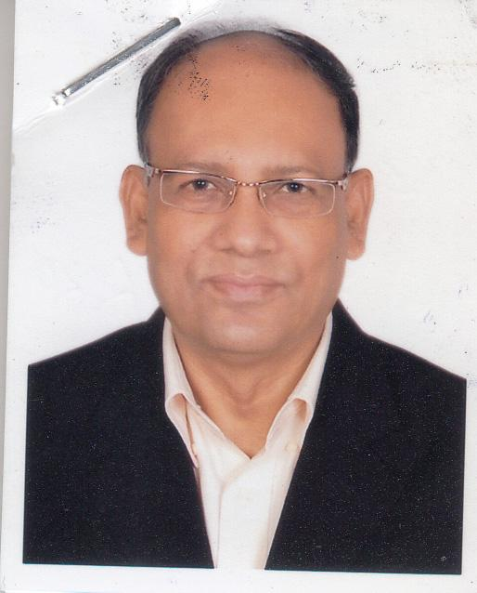 | MD. ZAKIR HOSSAIN KHANDKER  F/Name: Md. Abdus Salam Khandker  M/Name: Zahanara Khatun  BM & DC Reg. No: 14663  NID: 6873097551  Cell: 01765260393  Address: Vill- Baniaganti, P.O- Chandan Ganti, Upazila-Belkuch, Dist,- Sirajganj  Blood Group: O+
128 | Voter No  LM-6200128  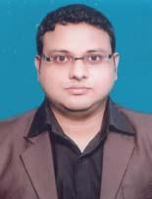 | DR. MUSFIQ ANJUM AMIO  F/Name: Late. Dr. Md. Abul Masud  M/Name: Rownak Ara  BM & DC Reg. No: 67410  NID: 3278002401  Cell: 01717137588  Address: Janpur, Bankpara Sirajganj Sadar, Sirajganj.  Blood Group: O+
129 | Voter No  LM-6200129  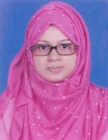 | DR. SUMONA HAQUE  F/Name: Shamsul Haque Nuri  M/Name: Zahanara Haque  BM & DC Reg. No: 124208  NID: 7321820891  Cell: 01616519429  Address: S.S Road, Sirajganj  Blood Group: A+
130 | Voter No  LM-6200130  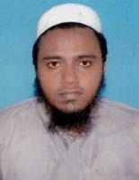 | DR. MD. PERVEZ RAHMAN  F/Name: Md. Ataur Rahman  M/Name: Mrs. Perven Akter  BM & DC Reg. No: 51953  NID: 5956439284  Cell: 01755615306  Address: Khwaja Yunus Ali Medical College Enayetpur, Sirajganj.  Blood Group: O+
131 | Voter No  LM-6200131  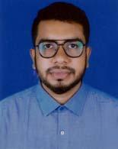 | DR. MD. RAGIB AHASAN MUNNA  F/Name: Haji Md. Mozammel Hoque  M/Name: Mst. Hasina Begum  BM & DC Reg. No: 108890  NID: 1463198356  Cell: 01308054380  Address: Vill: Thakurjee Para Post: Boiddo Jamtoil Thana: Kamarkhand Dist: Sirajganj.  Blood Group: B+

